Appendix A: A La Carte Fee Schedule

This fee schedule is valid for the 2025 tax year and is not transferable to any other year or entity.
Unless noted, fees are charged per return per tax year.

INDIVIDUAL TAX RETURNS
1040 1040NR 1040SR 1040X $400

The following forms are included in the base return price:
Schedule A (Itemized Deductions)
Schedule B (Interest & Dividends)
Schedule D (Capital Gains & Losses)
Schedule SE (Self Employment Taxes)
1040-ES (Estimated Taxes)
8582 (Passive Activity Loss Limitations)
8949 (Sales and Other Dispositions of Assets
8959 (Additional Medicare Tax)
8960 (Net Investment Income Tax)
8889 (Health Savings Accounts)
One Resident State Tax Return

ADDITIONAL FORMS
Schedule C (Profit or Loss from Business) +$150 per business entity
Schedule E (Supplemental Income and Loss) +$150 per business entity
Schedule F (Profit or Loss from Farming) +$150 per business entity
Schedule H (Household Employment Taxes) +$50 per employee
Form 8606 (Nondeductible IRAs) +$50 per form
Form 8283 (Noncash Charitable Contributions) +$50 per form
Form 2441 (Child and Dependent Care Credit) +$25 per form
Form 1116 (Foreign Tax Credit) +$25 per form
Form 8834 (Qualified Electric Vehicle Credit) +$25 per form
Other Credits & Deductions +$25 per form
Additional State(s) Tax Return +$150 per state
Form 5471 (Foreign Shareholder) +$200 per business entity
Form 926 (Foreign Corporation) +$200 per business entity
Form 8865 (Foreign Partnership) +$200 per business entity
Form 8858 (Foreign LLC) +$200 per business entity
Form 3520 (Foreign Trust) +$200 per business entity
Form 8833 (Foreign Treaty Disclosure) +$200 per form
Form 2555 (Foreign Earned Income Exclusion) +$200 per form
Form 8938 (Statement of Specified Foreign Assets) +$25 per foreign account
Form 114 (Foreign Bank and Financial Accounts) +$25 per foreign account

An additional rate for complexity may be charged for the following situations:
Tax elections
Missing or incorrect depreciation
Adjustments
Change in accounting method
Noncovered shares
Missing cost basis
Amended tax returns
Filing status analysis
ISOs and RSUs

ESTATE AND TRUST TAX RETURNS
1041 $800

An additional rate for complexity may be charged for the following situations:
Fiscal-year reporting
Section 645 election
Charitable remainder trust reporting
Final return
Alternative valuation date
Generation skipping tax

BUSINESS TAX RETURNS
990 (Nonprofits) $1200
1065 (Partnerships) $1200
1120 (Corporations) $1200
1120-S (S Corporations) $1200

An additional rate for complexity may be charged for the following situations:
Income apportionment
Basis
Transfer of owners
Formation/Dissolution
Disposal of business assets
Net profit analysis/modification for retirement
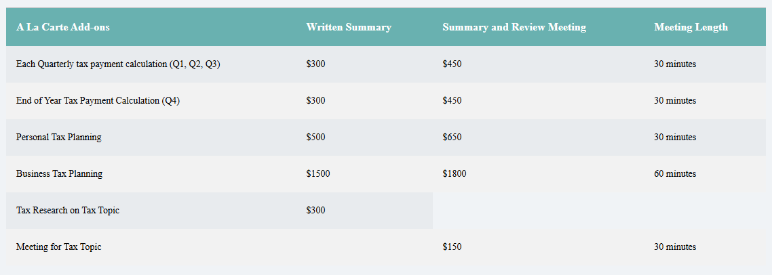

Appendix B: Subscription Fee Schedule

This fee schedule is valid for the 2025 tax year and is not transferable to any other year or entity. Packages are charged up-front annually, with the option to pay in monthly, interest-free payments. Cancelled subscriptions revert to a-la-carte pricing.

Planning Lite Package $2400 per year
One Annual 1040 tax Form Preparation and Filing
Quarterly tax payment calculation for Quarter 1, Quarter 2, and Quarter 3
End of Year Tax Payment Calculation for Quarter 4
Annual Personal Tax Planning

Planning Package $3600 per year
One Annual 1040 tax Form Preparation and Filing
Quarterly tax payment calculation for Quarter 1, Quarter 2, and Quarter 3
End of Year Tax Payment Calculation for Quarter 4
Annual Personal Tax Planning
Annual Business Tax Planning

VIP Package $6000 per year
One Annual 1040 tax Form Preparation and Filing
Quarterly tax payment calculation for Quarter 1, Quarter 2, and Quarter 3
End of Year Tax Payment Calculation for Quarter 4
Processing of Quarterly tax payments
Annual Personal Tax Planning
Annual Business Tax Planning
Unlimited Tax Research on Tax Topics

